A000-Asia-China-Liangshu-Cong-Square-Four Tiers-Jade-3300-2250 BCE

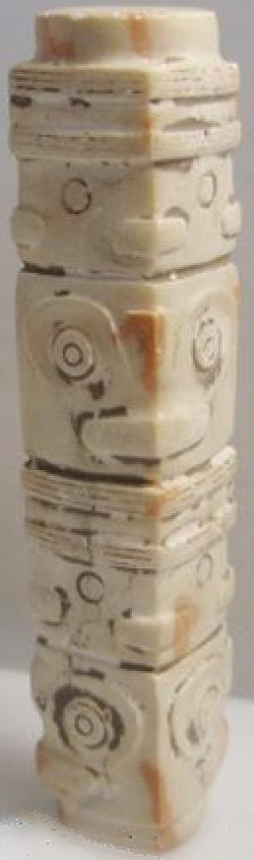

Fig. 1. China-Liangshu-Cong-Square-Four Tiers-Jade-3300-2250 BCE

Case no.: 5

Accession Number:

Formal Label: China-Liangshu-Cong-Square-Four Tiers-Jade-3300-2250 BCE

**Display Description:** Jade cong were first introduced by the Liangzhu culture, lower Yangzi River Valley, 3300-2250 BCE. They served as memorial sculptures of deceased ancestors. Their structure is tube-like with geometrically arranged surfaces on which are carved highly abstract anthropomorphic visages meant to indicate the ancestor to be remembered. They can have several tiers of these visages and in the larger cong the succeeding tiers are always slightly larger in diameter than the previous ones, so these cong have the appearance of expanding volumes from the base. Cong have been found carefully laid on or beside the bodies of the deceased.

**LC Classification:** NK5750.2.A1

Date or Time Horizon: Liangzhu culture, lower Yangzi River Valley, 3300-2250 BCE

Geographical Area: Liangzhu culture, lower Yangzi River Valley

**Map:**

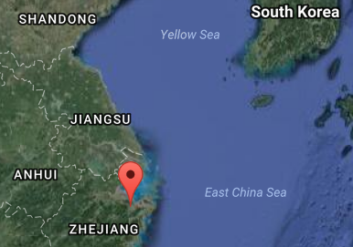

Source: Google Earth

**GPS coordinates:**

Northeast corner: N 30°24'48", E 120°00'17"

Northwest corner: N 30°24'41", E 119°58'58"

Southeast corner: N 30°23'20", E 120 00'19"

Southwest corner: N 30°22'55", E 119°58'28"

Cultural Affiliation: Liangzhu culture, lower Yangzi River Valley, 3300-2250 BCE

Medium: Jade

Dimensions: 1.4 cm., 1.4 cm., 7.8 cm.

Weight:

Condition: original

Provenance:

**Discussion:**

Liangzhu (3400–2250 BCE) in Yuhang County, Zhejiang, was a highly stratified Neolithic jade city-state in the Yangtze River delta where élites controlled a sphere of influence north to Shanxi and south to Guangdong.

DNA recovered from Liangzhu graves shows high frequencies of Haplogroup O1 linking it with modern Austronesians.

The use of jade and other expensive wares (such as silk, lacquerware, and ivory) in grave sites characterized the social symbolism of Liangzhu élites. About 4200 BP Liangzhu succumbed to a series extreme floods since the cultural layers are interrupted by intrusions of mud and sand. It is also possible that an asteroid created Taihu lake 4500 BP, which contributed to its demise.

**References:**

Chang, K.C., Xu, P. and Lu, L. 2005. *The formation of Chinese civilization: an archaeological perspective*. New Haven: Yale University Press.

Li, Hui; Huang, Ying; Mustavich, Laura F.; Zhang, Fan; Tan, Jing-Ze; Wang, ling-E; Qian, Ji; Gao, Meng-He; Jin, Li. 2007. "Y chromosomes of prehistoric people along the Yangtze River," Human Genetics **122**: 383–388.

Wu, Li. 2014. "Holocene environmental change and its impacts on human settlement in the Shanghai Area, East China," Catena. **114**: 78–89

Zhang, Chia; Hsiao-Chun, Hung. 2008. "The Neolithic of Southern China–Origin, Development, and Dispersal,"Asian Perspectives. **47**:2, 309–310.

Zhou Ying. 2007. "The Dawn of the Oriental Civilization: Liangzhu site and Liangzhu culture. Beijing: China Intercontinental Press.

